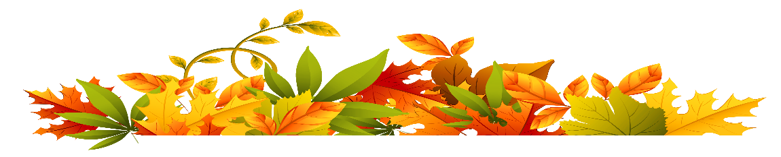

**Save the Date!**

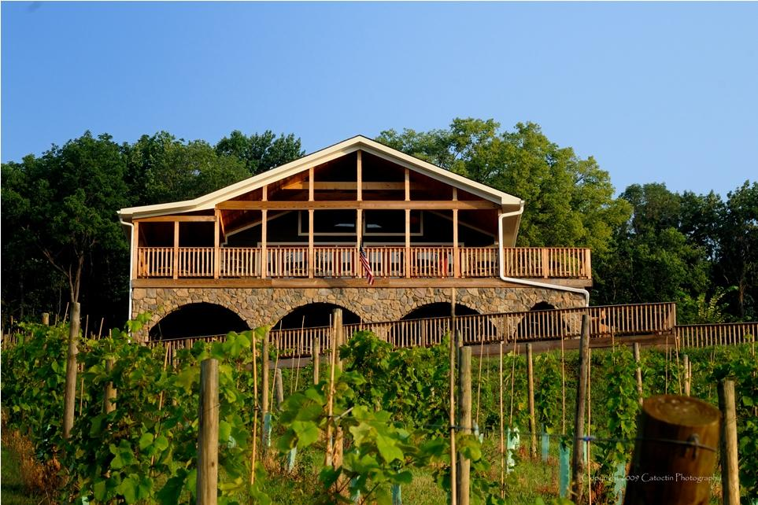

***Friends of the Blue Ridge Mountains***

**Annual Meeting & Member Celebration**

**Thursday, November 14th**

**6:30 – 9:00**

**Bluemont Vineyard**

