6/9/2022
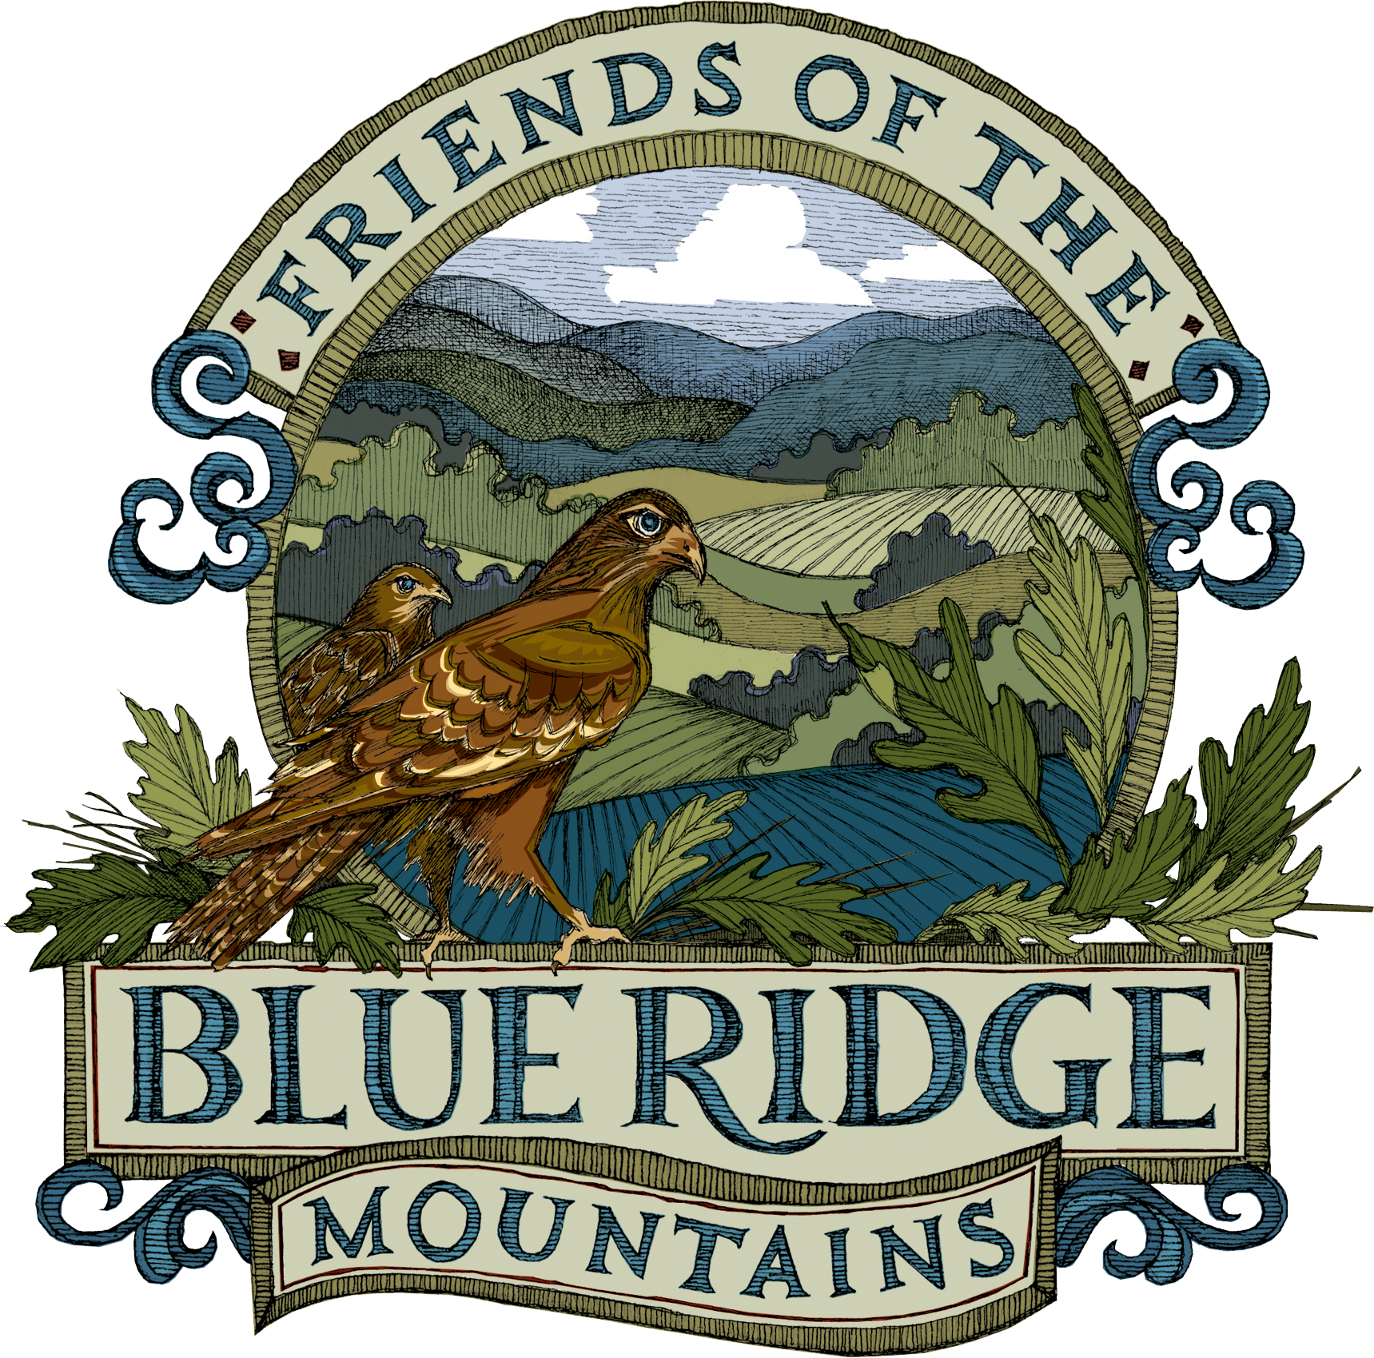

Friends of the Blue Ridge Mountains
Comments
Section 4.04 -- Mountain Development Overlay District (MDOD)

- Section 4.04 B.1. a. Applicability: Both the current and the proposed Zoning Ordinance defines the Mountain Development Overlay District (MDOD) on the basis of soil types and steep slopes. The definition is too narrow in that it fails to consider a mountain as one interconnected whole. Defining the MDOD by soil type and steep slopes would result in a patchwork district that would not cover the entire area of a mountain. The MDOD must be defined so as to protect the entire mountain from inappropriate development and use.

- FBRM Recommendation -- This draft Zoning Ordinance should be revised to define the MDOD geographically. FBRM recommends:
- that there should be only one MDOD that includes the entirety of any mountain.
- that this MDOD's boundary should be defined to follow around the base of the mountain; and
- that the entirety of the elevated terrain above that boundary should be included in the MDOD.
FBRM recommends that a mountain's base be defined as that encompassing line where the surface slope at a mountain's base first exceeds 8%. [Generally, this 8% slope boundary can be obtained from USDA soil type maps.]
This definition will result in a clearly defined, contiguous MDOD that overlies the entire mountain region, above where the flat or undulating land at its base first steepens to form the elevated mountainous terrain.
- Section 4.04 C Uses and Activities: Both the current and the proposed Zoning Ordinance allows all uses permitted in Zoning Districts Rural North (RN) and Rural South (RS) – formerly designated AR-1 and AR-2 – to be permitted in the MDOD.

Not all of the permitted uses in these districts are appropriate for the delicate MDOD environment. Allowing all RN and RS uses will result in inappropriate development and over development, the consequences of which would be to risk the degradation of the several environmental values enumerated in FBRM's following recommendation regarding Section 4.04 E. and F. Development and Design Standards.

The geology, topography and ecology of mountainous regions require special care to preserve the intrinsic environmental values associated with these regions. Some uses appropriate to rural low-land areas in the Piedmont region are incompatible with preserving mountainous environmental values, while other uses may only be acceptable if judiciously controlled by issuance of a Special Exception permit.

♣ FBRM Recommendation: Developments in the MDOD should be constrained to a separate and narrower table of allowable uses. See Table #1 for a list and discussion of the specific changes to the permitted uses in the MDOD.

- Section 4.04 E. and F Development and Design Standards: The new Zoning Ordinance must include performance and design standards unique to the needs and conditions of the Mountain environment.
♣ FBRM Recommendation: Specific Mountain environmental value protections that should be included in this MDOD section. See Table #2 for a list and discussion of the 12 environmental values that FBRM recommends.
- Section 7.13 Enforcement: We need a system of enforcement and oversight by requiring construction permits and plan reviews for all clearing, grading, and construction in the MDOD.

  - FBRM Recommendation: Zoning enforcement within the MDOD should be guided by two principals: 1) The penalties for serious zoning violation should be sufficiently robust to discourage violation and not simply become a cost of doing business. 2) The penalties for serious zoning violations should require the violator to return the land to the condition it was in before the violation. It is not sufficient to stop the violation. The land must be returned to its original condition.
  - Specific wording changes include the following:

    - Section 7.13 B. 3. Zoning Administrator must take action to remove any violation or attempted violation of this Zoning Ordinance.
    - Section 7.13 B. 6. a. The Zoning Administrator will specify a reasonable time for the violation to cease and for the land to be fully returned to pre-violation condition.
    - Section 7.13E.10.b. In order to determine that a violation has been corrected the zoning administrator must determine that the land has been returned to pre-violation condition.

Land Conservation: FBRM Recommends that public policy should continue to encourage land conservation through programs such as Conservation Easements, PDRs, TDRs, and other tools that limit development and promote passive recreation uses in the MDOD.

Table #1
FBRM Recommends modifications to Zoning Ordinance Table 3.02.03-3
Principal Use Table for Rural Policy Areas

Categories | FBRM Comments
Household Living | The negative impact of residential uses in the MDOD is directly related to density. FBRM proposes that residential uses, regardless of the specific type of dwelling, should be limited to no more than one structure per 10 acres.
Group Living

Lodging

Rural Resort | A Rural Resort should not be a permitted use in the MDOD. The MDOD environment is too fragile to accommodate the intensity of use associated with a rural resort.
Animal Services | FBRM has concerns regarding the density for animal services use. Any facility should be limited to 10,000 square feet per 10 acres.
Restaurant – sit down | A sit-down restaurant should not be a permitted use in the MDOD. The MDOD environment cannot accommodate the traffic and parking associated with a sit- down restaurant.
Snack or beverage bar | A snack or beverage bar should not be a permitted use in MDOD. The MDOD environment cannot accommodate the amount of traffic, parking and refuse associated with a snack or beverage bar.
Winery – Commercial | A commercial winery should not be permitted By Right in the MDOD and should only be permitted if in compliance with rigid performance standards regarding traffic generated, parking, noise, lighting, and waste disposal.
Personal/Business Services | Personal/business services should not be a permitted use in the MDOD because the MDOD environment cannot accommodate the traffic and parking associated with personal/business services.
Retail | Retail should not be a permitted use in the MDOD because the MDOD environment cannot accommodate the traffic and parking associated with retail.
Assembly | Assembly uses should not be permitted in the MDOD because the MDOD environment cannot accommodate the traffic and parking associated with Assembly.
Agricultural Education or research | Agricultural education or research should not be permitted By Right in the MDOD. The use should be permitted only in compliance with rigid performance standards regarding traffic generated, parking, noise, and lighting. The definition of an Agricultural Education or Research facility does not include any reference to scale or intensity and thus its impact upon the MDOD environment cannot be evaluated.
Rural Retreat | Rural Retreat should not be permitted By Right in the MDOD. Rural Retreat should be permitted only in compliance with rigid performance standards regarding traffic generated, parking, noise, and lighting.
Agricultural Cultural Center | Agricultural cultural center should not be permitted By Right in the MDOD. Agricultural cultural center should be permitted only in compliance with rigid performance standards regarding traffic generated, parking, noise, and lighting. The definition of an Agricultural Cultural Center does not include any reference to scale or intensity and thus its impact upon the MDOD environment cannot be evaluated.
Agritainment | Agritainment should not be permitted By Right in the MDOD. Agritainment should be permitted only in compliance with rigid performance standards regarding traffic generated, parking, noise, and lighting. The definition of an Agritainment facility does not include any reference to scale or intensity and thus its impact upon the MDOD environment cannot be evaluated.
Amphitheater | Amphitheater should not be a permitted use in the MDOD. The MDOD environment cannot accommodate the traffic, parking, noise, and lighting associated with an amphitheater.
Cultural Tourism | Cultural Tourism should not be a permitted use in the MDOD. The MDOD environment cannot accommodate the traffic and parking associated with cultural tourism. The definition of a Cultural tourism facility does not include any reference to scale or intensity and thus its impact upon the MDOD environment cannot be evaluated.
Sawmill | A sawmill should not be a permitted use in the MDOD. The MDOD environment cannot accommodate the noise, traffic, parking, and waste product associated with a sawmill.
Transportation Parking | Transportation uses should not be permitted in the MDOD. The MDOD environment cannot accommodate the traffic, and parking associated with transportation uses.
Communications Facilities | Communication facilities should not be a permitted use on the ridge line. This is current County policy and currently a county zoning restriction. The policy and restriction should be maintained in any amendment to the County zoning ordinance.
Agriculture | Agriculture, farm distribution hub, winery, commercial and winery, Virginia farm should not be allowed By Right in the MDOD. Each of these uses has the potential to negatively impact the delicate MDOD environment in a significant way because of associated traffic, parking, noise, lighting, and waste product. Each use should be permitted in the MDOD only in compliance with rigid standards protecting the MDOD environment.

Table #2

FBRM Recommends 12 environmental standards
to guide development in the MDOD

CATEGORIES | FBRM COMMENTS
Preserve natural ridgeline features | The maintenance of a closed forest canopy for the highest 100 vertical feet along any ridgeline or crest, with no development projecting above the canopy, should be required without exception.
Retain forest canopy | All development proposals should maintain the forest canopy in as closed a condition as is practicable, thus precluding clear cutting forestry projects, concentrated parking lots, etc.
Control erosion | The water courses found in mountainous regions must be meticulously kept free of added sediments and other pollutants in order to maintain local benthic water quality, and meet downstream water quality standards, thus requiring the use of technologies capable of preventing run-off water from reaching any stream channel.
Prevent landslides and slumps | Mountain slopes are inherently unstable geologically, requiring that very strict controls on removal of vegetative cover and disturbance of soils must be adhered to, so as to prevent development activities from creating increased landslides and slumping risks; the requirements in the draft ordinance are too weak to achieve these goals, and should be strengthened accordingly.
Preserve upland stream water quantity and quality | Mountain springs and headwater water courses are a critical component of the hydrological system serving natural and human water needs, yet these features are highly sensitive to nearby and upslope developments, especially those developments involving vegetation removal or soil disturbance; the draft setback requirements may be insufficient to achieve the required protections.
Protect ground water recharge areas | Mountainous regions are a prime source for recharging ground water aquifers that supply much of our developed water supply, thus making it imperative that these recharge areas be identified and protected from any development that would diminish their recharge capacity.
Minimize impervious surfaces, and require mitigation | Impervious surfaces such as rooftops and asphalted roads can be highly disruptive to the natural hydrological flow, so to the extent feasible their use must be limited in mountainous regions, and their runoff strictly regulated so as not to impact the functioning of natural water courses or to create sheet flow runoff.
Retain rural unpaved roads as per current Loudoun County policy | Loudoun's unpaved rural roads are a part of its historical patrimony and are generally more environmentally compatible than paved replacements would be, thus making their retention desirable.
Protect wildlife habitat and migration corridors | Mountainous regions are rich in wildlife habitats and are a primary location of wildlife migration corridors; as such these environmental assets are sensitive to development, so MDOD development restrictions should protect wildlife habitats and migration corridors.
Protect air quality and visibility | Air pollution emissions from elevated terrain is more visible from distant vantage points and is more prone to travel greater distances to impact other areas; additionally, mountain ecosystems are more sensitive to polluted air resulting in potential decline of critical vegetative cover.
Preserve dark skies | Light pollution from ill designed lighting systems results in unnecessary visible loss of nighttime sky features and can be avoided by use of purposefully designed lighting elements.
Avoid intrusive encroachments on the Appalachian Trail corridor and prime viewsheds | The Appalachian Trail (AT) is an important historical, cultural, and economic resource for Loudoun County, so measures are warranted to avoid development encroachments on the AT and its corridor and prime viewsheds that would be detrimental to its premier trail status.

