DRAFT # 2
7/28/22
Distribution

Insert FBRM’s masthead
7/28/2022 distribution

Introducing

Friends of the Blue Ridge Mountains (FBRM) is pleased to announce that it has hired its first ever Executive Director -- Larry Malone of Purcellville, Virginia.
According to Friends President, Peter Weeks “For fifteen years Friends has relied upon a volunteer Board of Directors and our membership to help preserve, enhance, and celebrate the Mountains. We are now pleased to take the next step and bring on an Executive Director to help us grow and help protect the Blue Ridge from increasing pressures of population growth and climate change.”
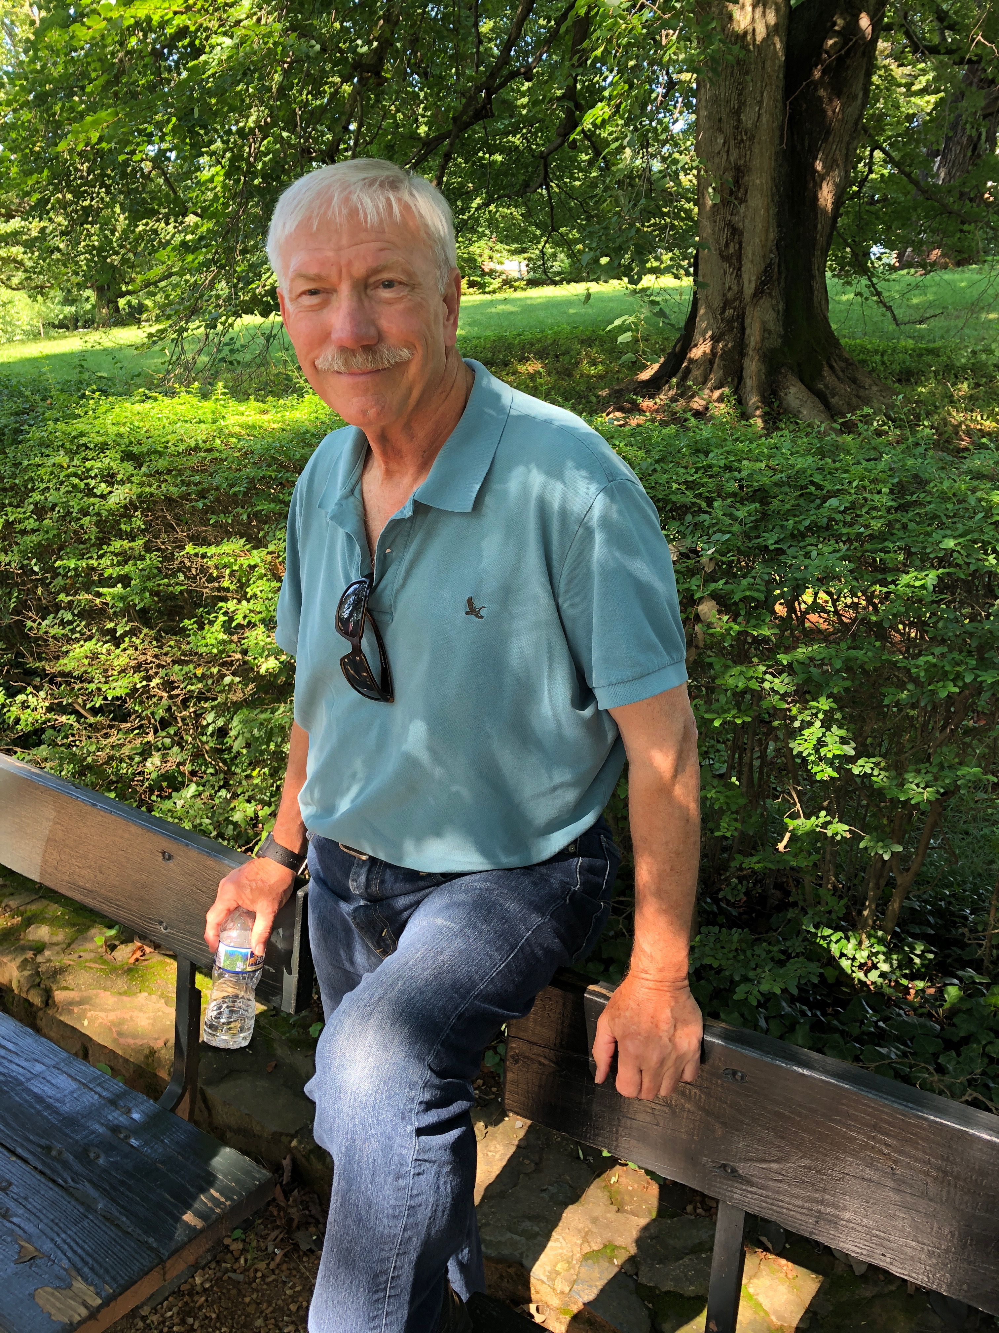
Larry has had a long and productive career working in business finance, city planning and public policy development. He worked for almost 15 years with several Public Interest Groups in developing policies and in representing their interests before congressional committees. He has also worked with two national consulting firms primarily assisting businesses secure expansion financing.
Perhaps more importantly for FBRM’s interests, Larry has backpacked through many miles of the Appalachian Trail, New York’s Adirondack Mountains as well as through Yellowstone, the Tetons and Glacier Park in the US and Jasper National Park in the Canadian Rockies.
This is the first of a series of short articles Friends will run in Happenings Around the Blue Ridge over the coming months. We want to introduce our readers to Friends Board of Directors and other individuals actively involved in helping develop public policy regarding the Blue Ridge Mountains and protecting the Mountains from the development pressures that are growing daily.

August 7 – Luckettes Trail Ride or Historic Hike

On Sunday August 7th the Virginia Piedmont Heritage Area is sponsoring two events in historic Lucketts. The town of Lucketts has played an important part in the history of Loudoun County, from early Native Americans, through the 18th Century and American Civil War.
In the morning, from 9:00 AM to approximately 11:30 AM Piedmont Heritage is sponsoring a trail ride. Participants are responsible for providing their own horse and riding equipment. They must be able to control their horse and remain with the group behind the leader. Protective ASTM/SEI approved hard helmets are required. Water and snacks will be provided. You are encouraged to bring your own tailgate lunch. All riders must provide Coggins Papers upon arrival. Tickets are $40.
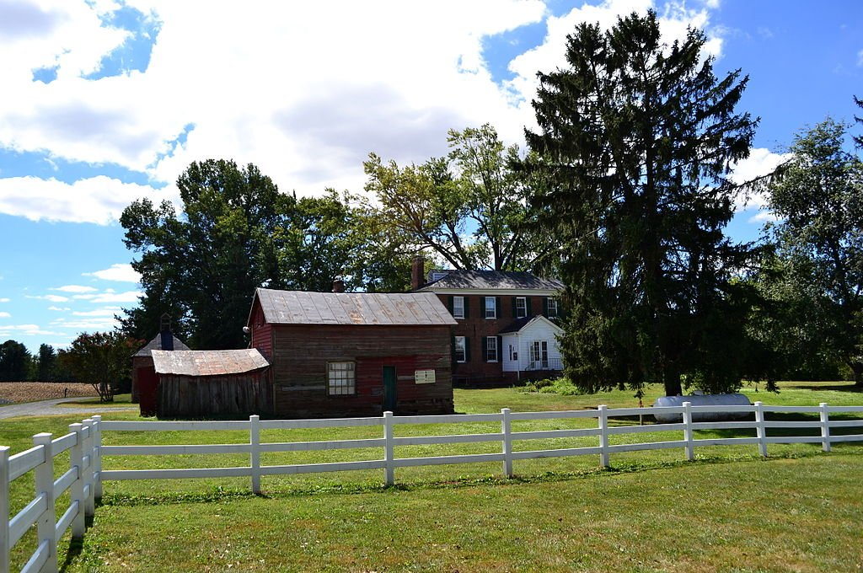
In the afternoon of the 7th from 1:00 PM to approximately 4:00 PM Piedmont Heritage is sponsoring a historic hike near Temple Hall. The hike will be guided by professional interpreters, with stops to highlight different stories. The total distance is approximately 3 miles of rolling terrain. Please wear comfortable hiking shoes, dress appropriately for the weather, and bring plenty of water. Water and snacks will be available. Tickets are $30.
For information about either event or to register go to https://www.piedmontheritage.org/events

August 13 – Bat Night

Loudoun Wildlife Conservancy is excited to present Bat Night led by The Bat Lady, Dr. Susanne Sterbing, world-renowned bat expert and research professor at Johns Hopkins University.
Dr. Sterbing will present a fascinating audio-visual presentation followed by a question-and-answer period at the Barn at the Blue Ridge Center for Environmental Stewardship. The Barn is the building near the parking lot where the restrooms are located.
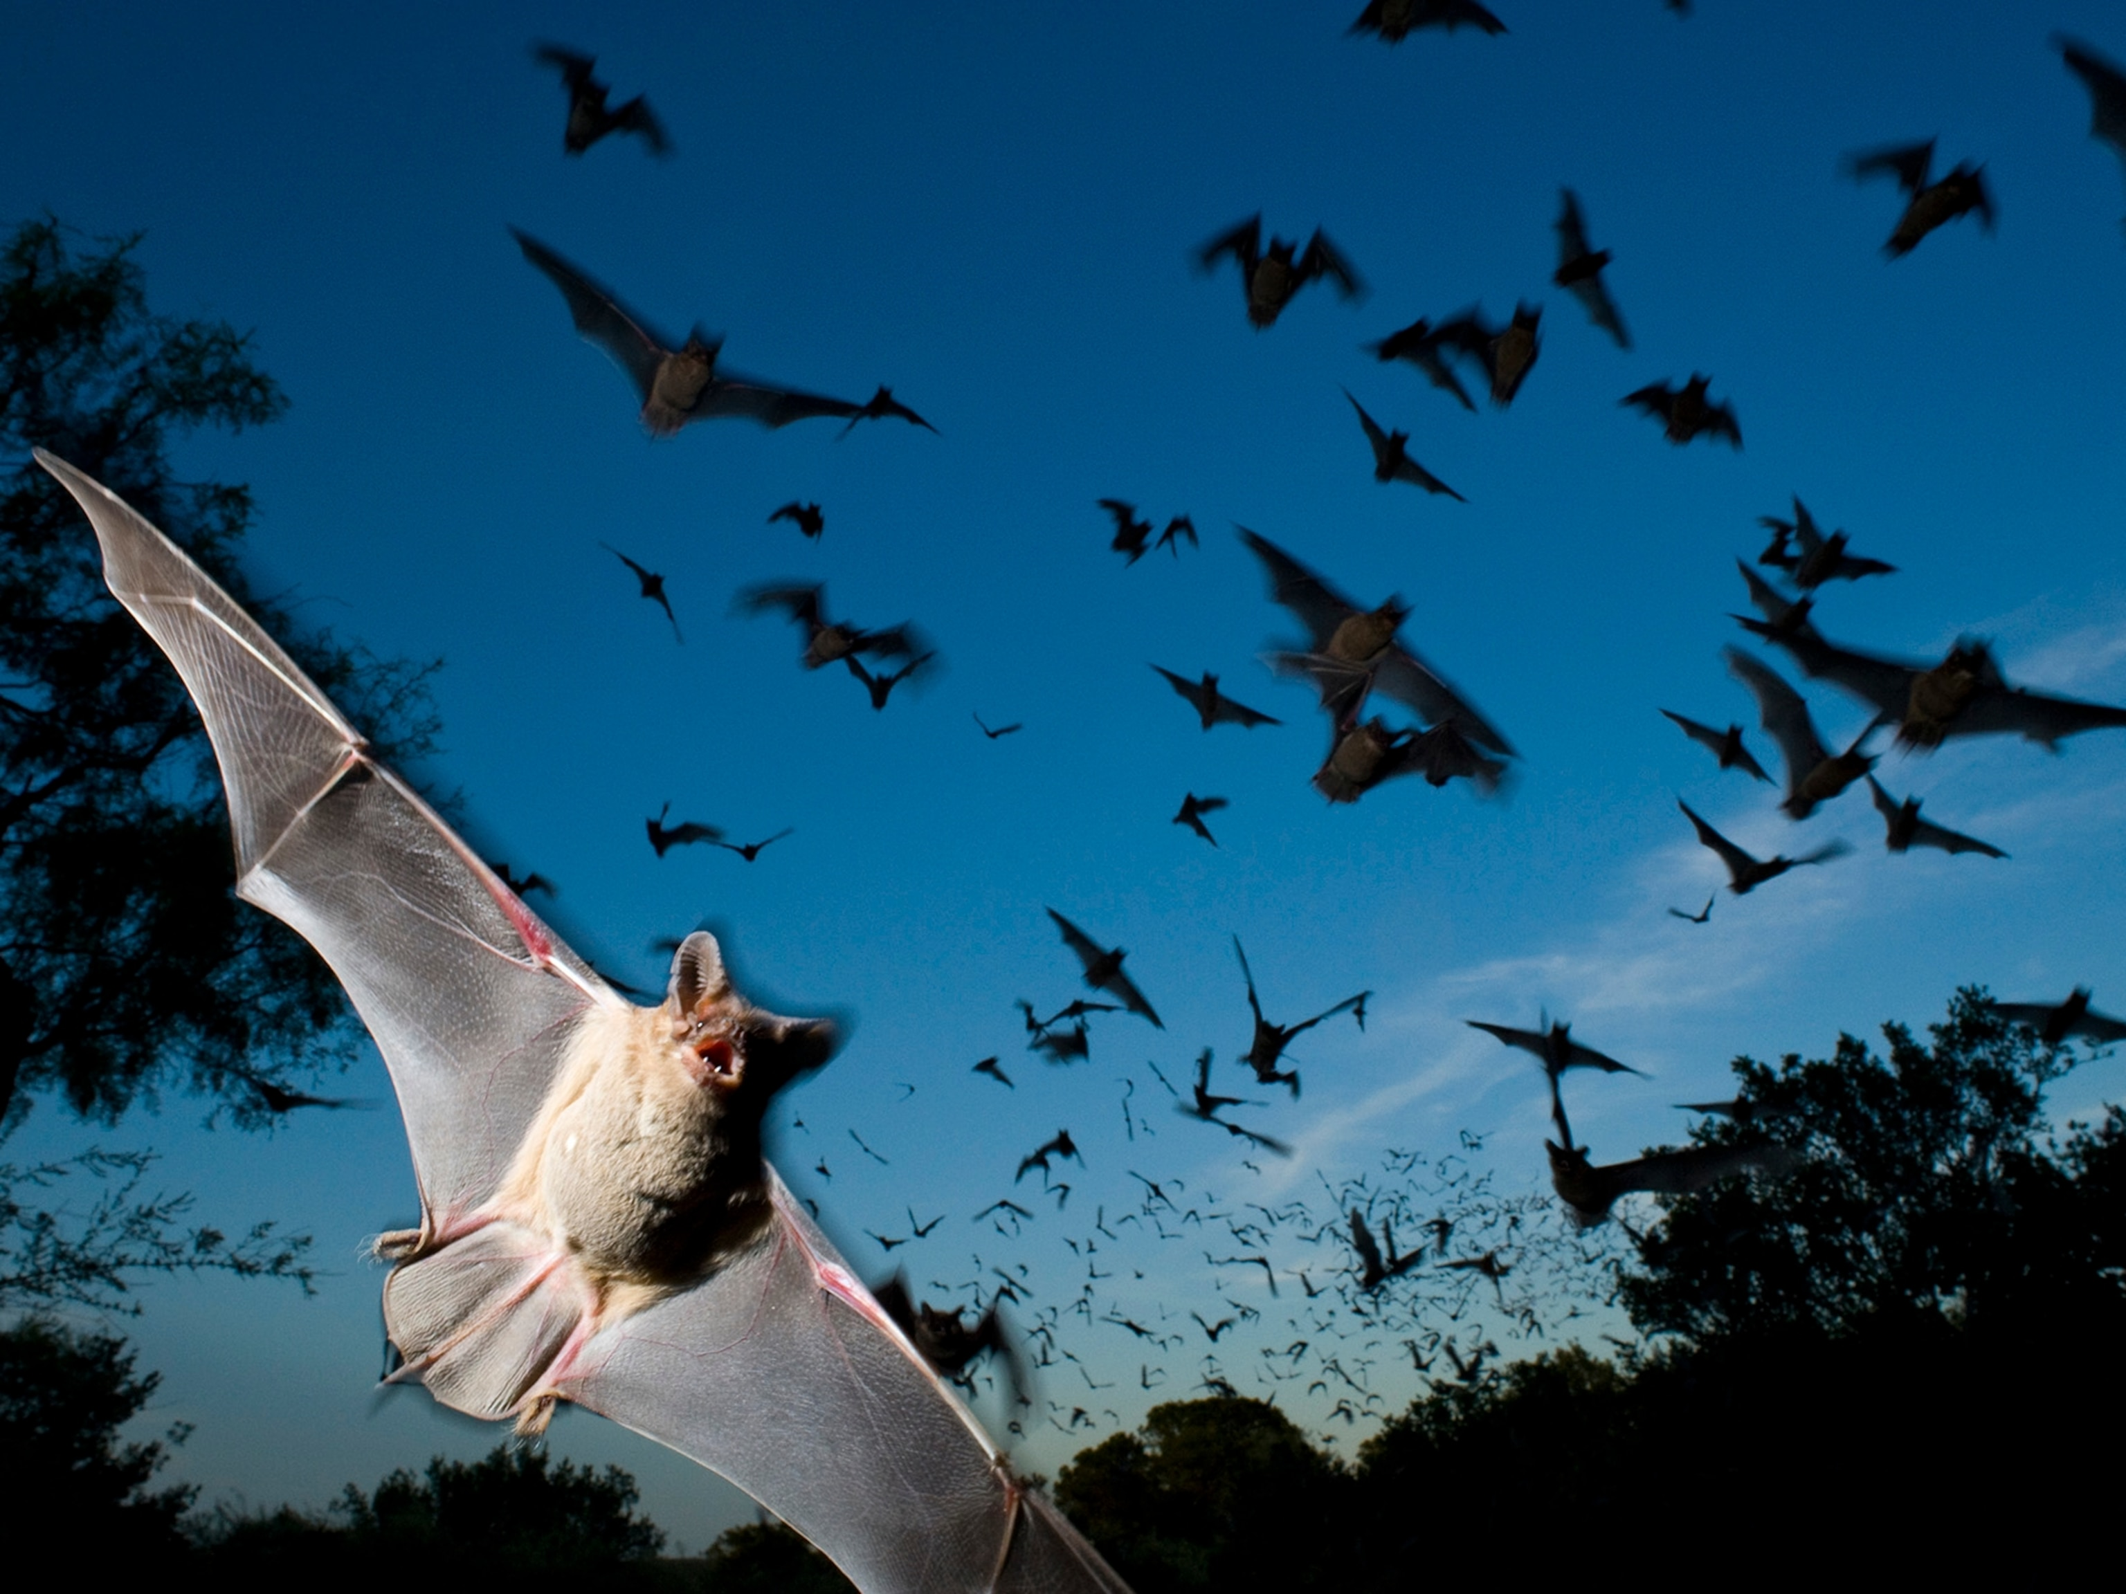
You don’t want to miss Dr. Sterbing’s description of the strange feeding rituals of vampire bats! The lecture will be followed by a live bat viewing (hopefully) down at the pond. Family friendly; wear good walking shoes and bring flashlights and bug repellant.

Limit 50. Registration require Questions: Contact info@loudounwildlife.org.

August 14 thru 20 – Clarke County Fair
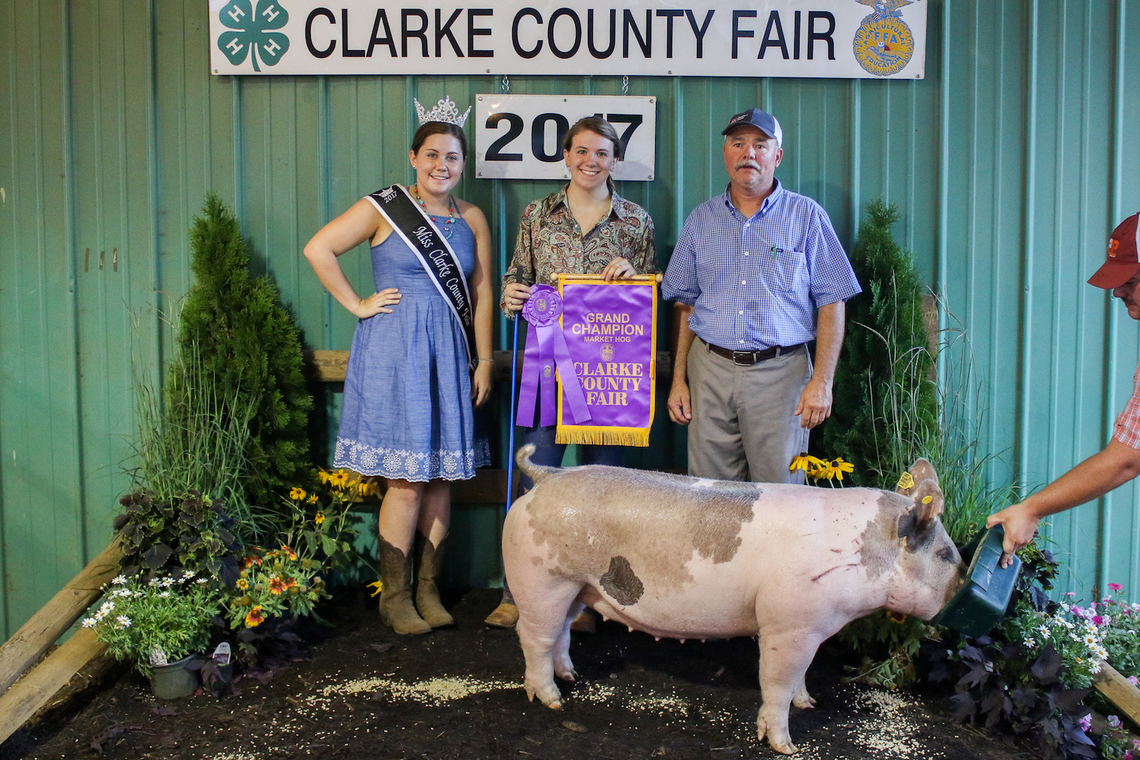
The 67th annual Clarke County Fair will officially open at 5:00 PM on Sunday 8/14/22 at the Clarke County Ruritan Fairgrounds located at 890 West Main Street, Berryville Va. and run through Saturday 8/20/22.

General admission is $10 for adults and $5 for children 5 to 15. Younger children are free.

In addition to carnival rides and animal exhibits there will be a number of special events including:

- Professional Bull Ride and Rodeo
- Baking contest

- Livestock Skillathon
- Kiddie peddle tractor pull, lawn and garden tractor pull, and truck pull
- Pig scramble
- Car and truck show
- The Cazhmiere Band

For more information and schedule of daily events and times go to https://clarkecountyfair.org/clarke-county-fair

August 17 -- Brown Bag Lunch: Spotted Lanternfly and Tree-of-Heaven
Join the Blue Ridge Partnership for Regional Invasive Species Management or PRISM on August 17 for its next Brown Bag Session (on-Line).

Take your lunch break and join Lori Chamberlain with the Virginia Department of Forestry and Tim Maywalt with Charlottesville Area Tree Stewards. They will discuss the relationship between tree-of-heaven (Ailanthus altissima) and the spotted lanternfly and how best to control each of these invasive species in late summer.

This is a free online webinar. However, a suggested donation of $5 would help Blue Ridge PRISM with the costs of this event and would allow them to provide more programs like it.

Go to https://blueridgeprism.org/ to register

August 28: Creek Critters of the Catoctin

Join the Purcellville Parks and Recreation Advisory Board, Purcellville Tree and Environment Sustainability Committee and Loudoun Wildlife Conservancy to get up close and personal with the creek critters living in the South Fork of the Catoctin Creek at the Chapman DeMary Trail.

Loudoun Wildlife Stream Team members will discuss the natural history of these critters, help participants learn how to identify them, and explain how they can help us determine the health of a stream.
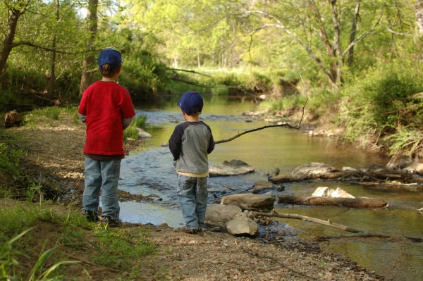

The event will begin at 1:00 PM. at 205 East Hirst Road, Purcellville.
Registration required through Purcellville Parks and Recreation website.

Questions: Contact Amy Ulland at aulland@loudounwildlife.org

September 24 – Bike the Gravel: Tour de Conservation Easement

Join the Land Trust of Virginia for the 5th Annual Bike the Gravel: Tour de Conservation Easement, a one-of-a-kind ride on scenic gravel roads and through gorgeous private properties of Loudoun and Fauquier Counties. Features include:

- A course that’s over 60% gravel.
- New properties never toured on previous rides.
- Something for every level – 18 miles, 34 miles and 65 miles
- Fully supported with SAG Wagons and well supplied rest stops at 3 locations.
- Registration includes gorgeous scenery and great gravel and paved road riding, pre-ride breakfast and post ride lunch, including beer in a stunning LTV pint glass!
- Begin and end at Buchanan Hall, Upperville, VA.
- Saturday, September 24th, 9:00 a.m. – Staggered start times to be assigned.
- Registration capped at 500 riders. Sign up today! Online registration deadline: Thursday September 22, 2022, 5:00 PM.
To register -- https://www.bikereg.com/bikethegravel-tdece
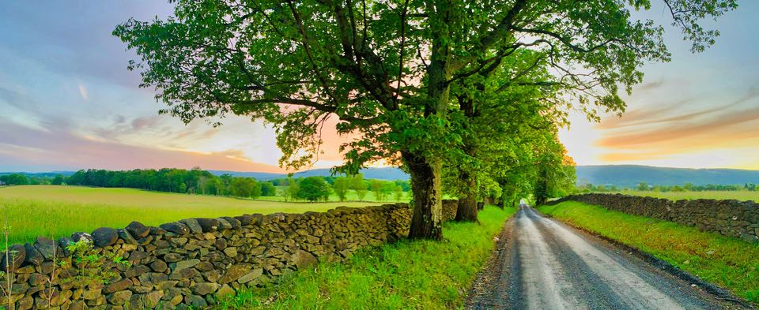
Joan, please insert thanking our sponsors and add B of A logo.
Thank you

Friends of the Blue Ridge Mountains

Friends of the Blue Ridge Mountains invites all individuals and families interested in preserving and celebrating the mountains to join our organization. We are a 501(c)(3) tax exempt organization so membership is fully tax-deductible.
For membership information and renewals, or to donate go to our website, www.friendsofblueridge.org.
